Taskify-backend Screenshots captured from Postman Prepared By Jayashree Das
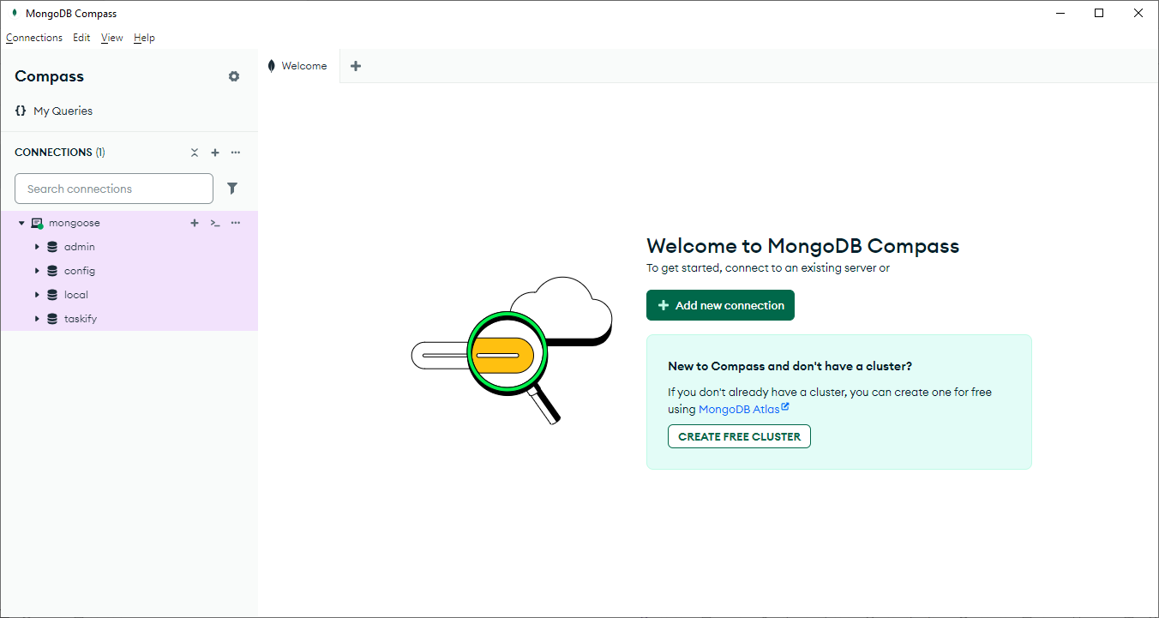

1. Create Task
Method: POST
URL: http://localhost:5000/tasks
Body (JSON):

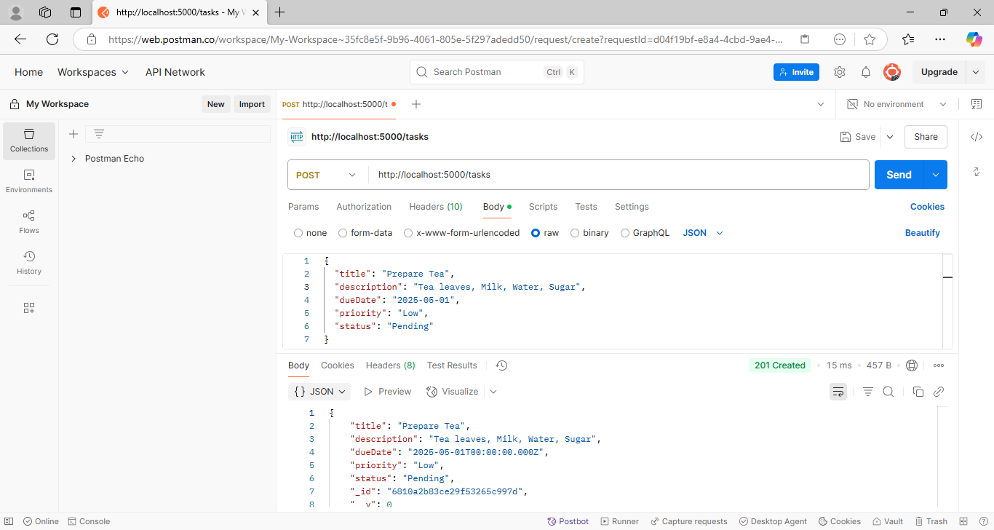

2. Get All Tasks
Method: GET
URL: http://localhost:5000/tasks
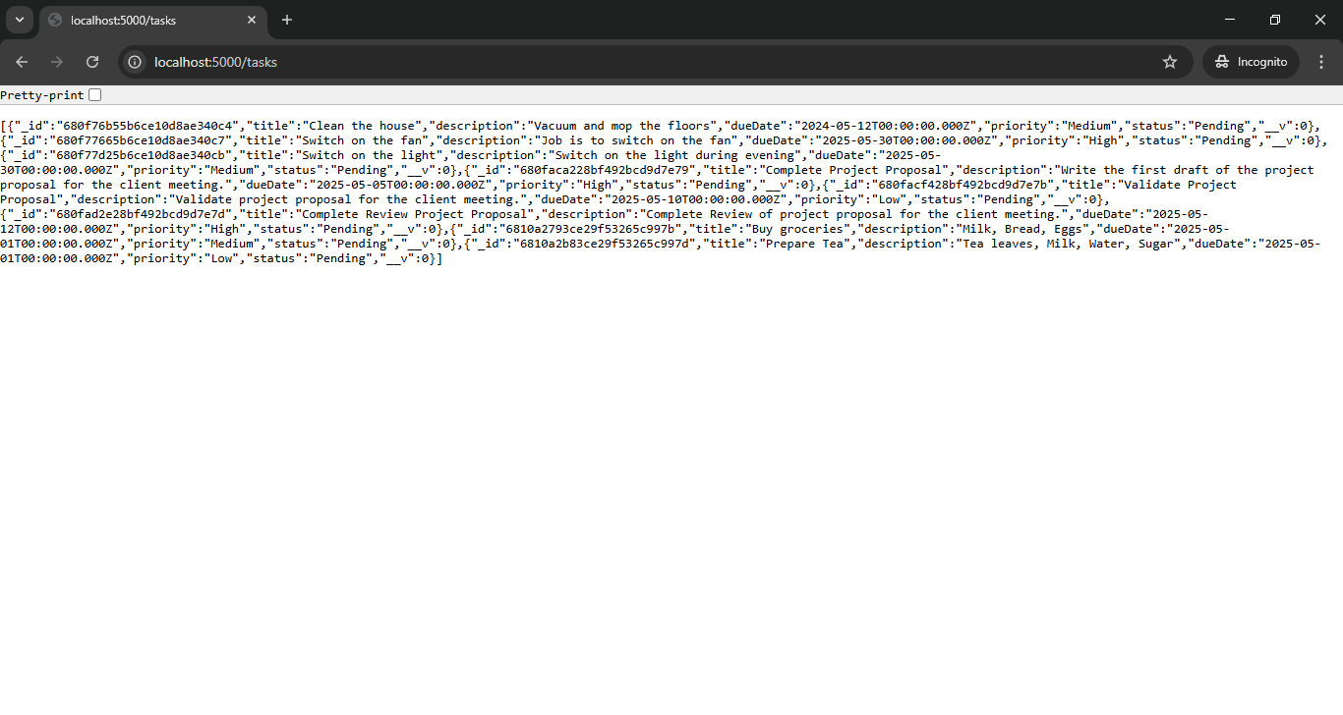
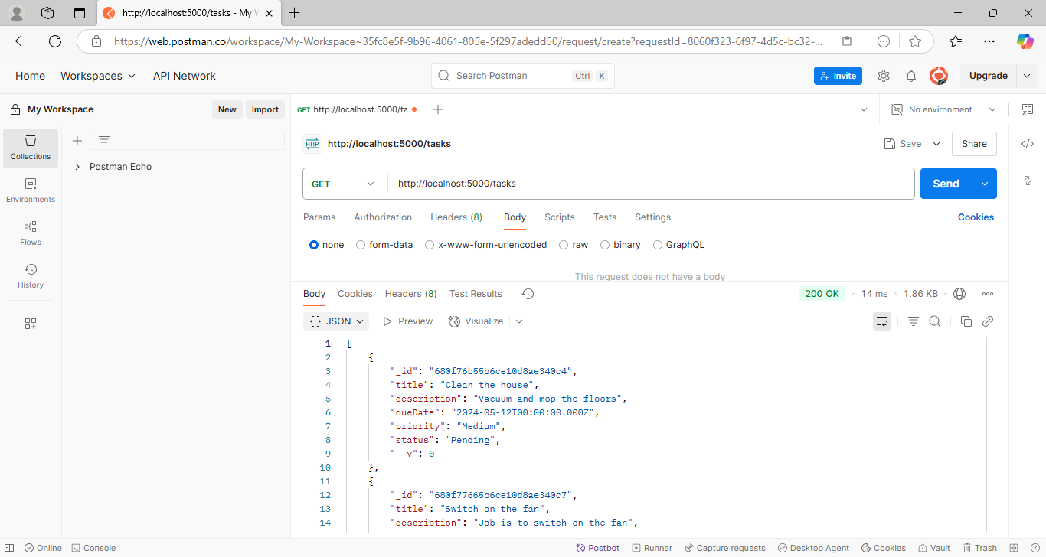

Method: GET
URL: http://localhost:5000/tasks
(Optional query params: ?status=Pending&priority=High)
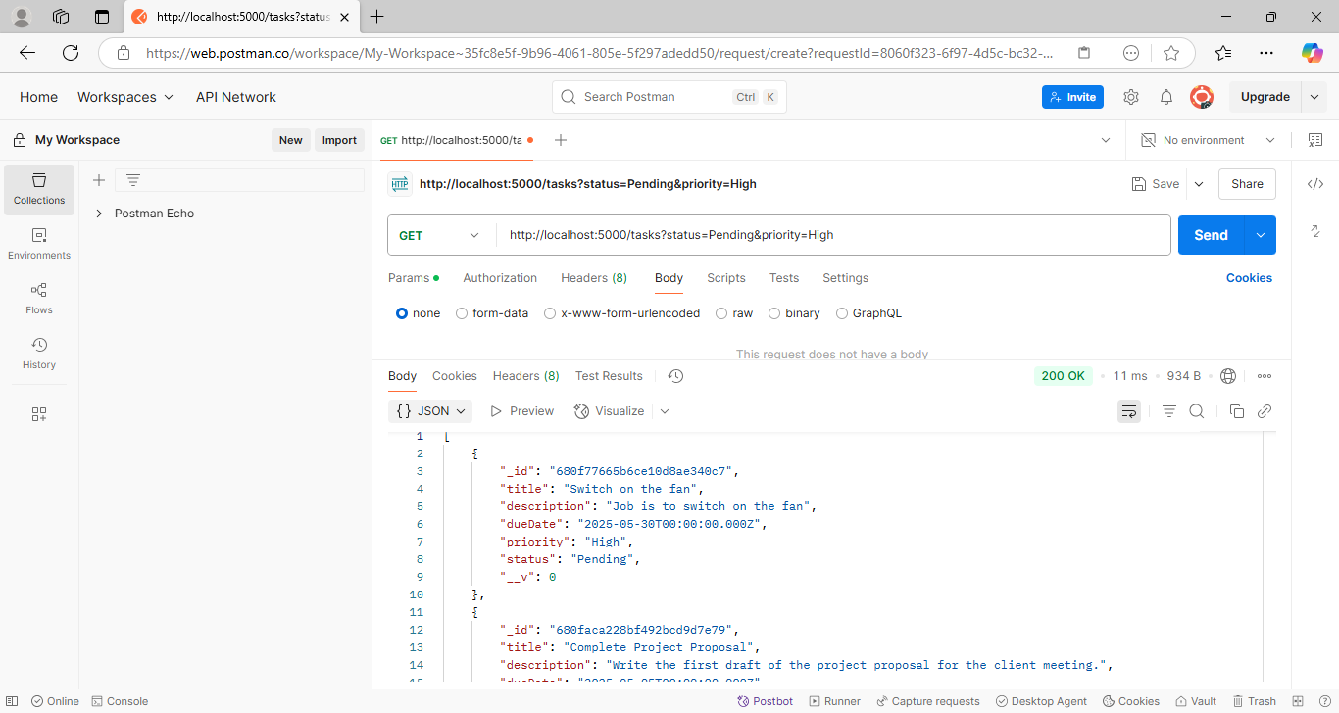
3. Get Task by ID
Method: GET
URL: http://localhost:5000/tasks/{task_id}
Replace {task_id} with a real ID from your DB.
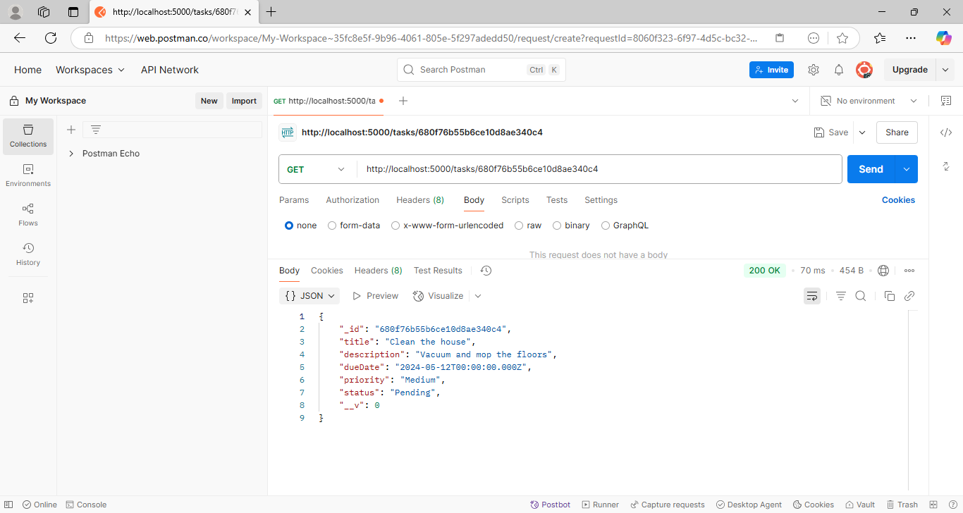
4. Update Task
Method: PUT
URL: http://localhost:5000/tasks/{task_id}
Body (JSON):
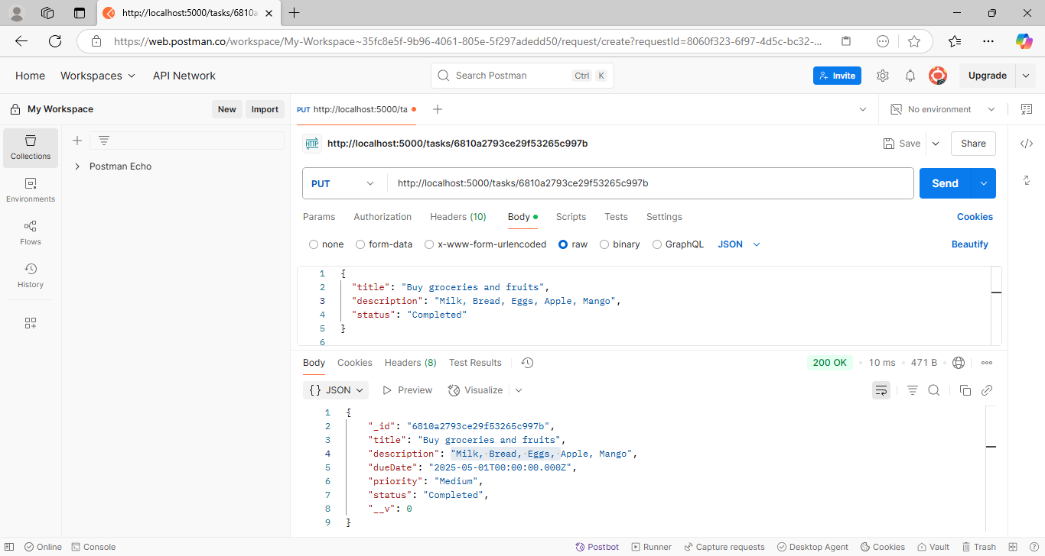

5. Delete Task
Method: DELETE
URL: http://localhost:5000/tasks/{task_id}
